**Chamberlain Web Application Assessment Notes by Nhlamulo Mabunda**

**Technologies Used:**

* MS SQL
* C#
* ASP.Net
* Javascript
* CSS
* Bootstrap
* Visual Studio as my IDE

**Overview of the whole application**

1. **Register form** – Each employee that must take a training should register using the Register Web form (screenshot attached below). The employee details will be stored in the Employee table.

* There is a **Role field** on the Register web form, the aim for this field was to separate an admin and a normal employee/staff. Admin was going to have access to **Add Trainings**, **Add Training Sessions**, **View Training Sessions** and **Export Training Sessions to CSV**, but a normal staff was going to have access only for **View Training Sessions** and **Export Training Sessions to CSV**. Please note that this functionality was not yet done due to time, but I have managed to cover almost everything indicated from the Spec.
* *Field validation is implemented to every web form.*

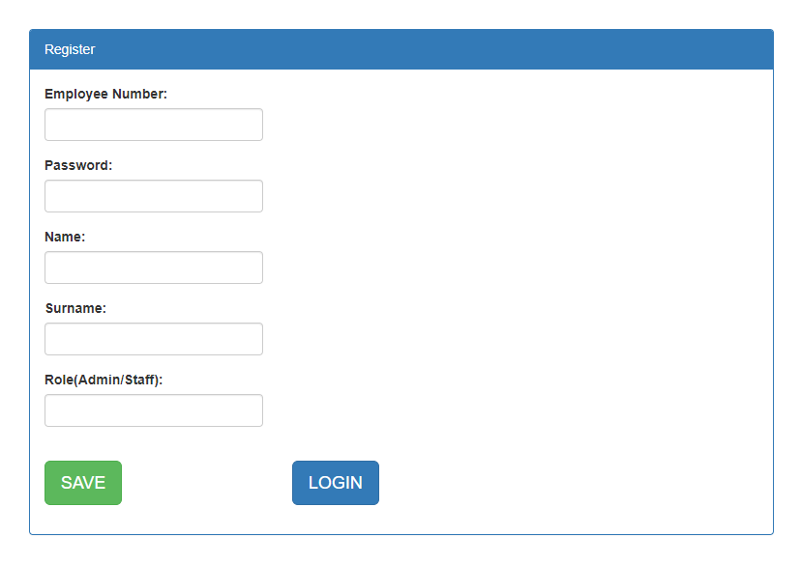

1. **Login Form** – A registered employee can login to the portal using the login web form (as indicated in the screenshot below)

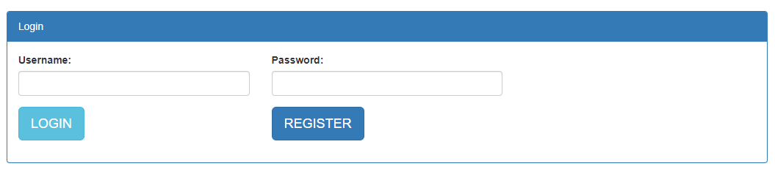

1. **Master Page** is created where the menu is linked to, it is a simple menu.

* If employee has successful logged in to the portal/application can be able to navigate through the menu as indicated on the screenshot below.
* **Home** – In this tab an employee can be able to *View Training Sessions* and *Export Training Sessions to CSV*.
* **Add Training** – Instead of adding training into database manually, I am using this Add Training form as indicated in the screenshot below to add trainings.
* **Add Session** – I am adding training sessions using this form. Trainee Name dropdown is populated from the Employees table, and Training dropdown is populated from Training table, the main reason for this I wanted to make sure only registered employee can be a trainee, and only registered/added training can be considered on training. I have added review field to make the report or CSV file to nicer.
* **LogOut** – An employee can be able to logout from the Home page.

**Home**

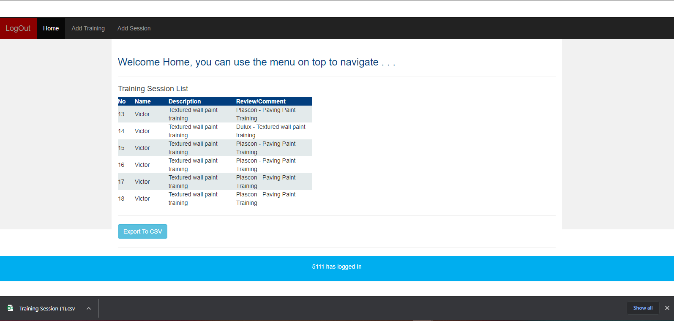

**Add Training**

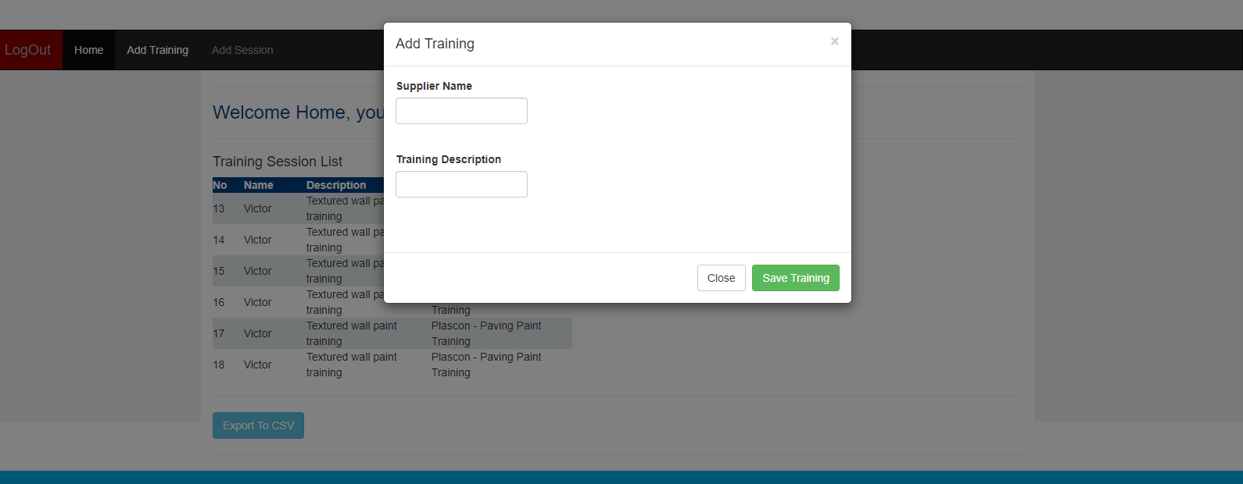

**Add Training Session**

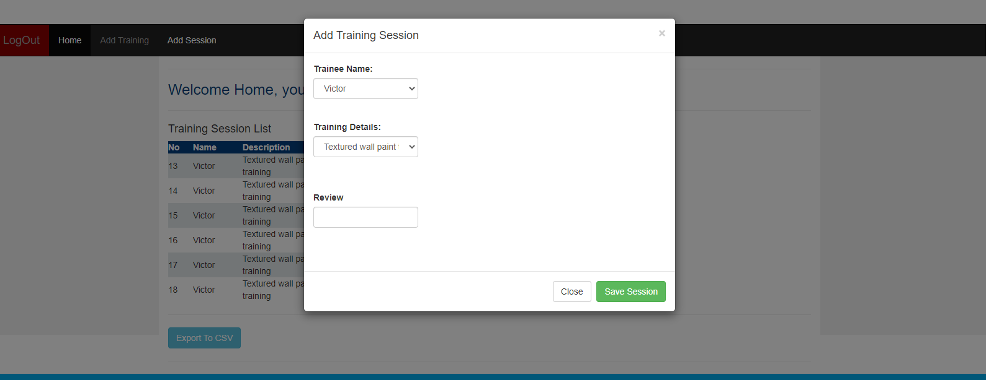

**Exported CSV file**

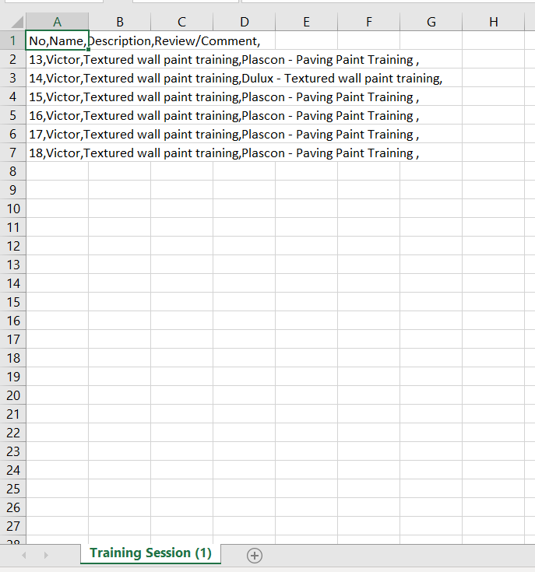

**MS SQL Database** with three tables used(Employees, Training and TrainingSession)

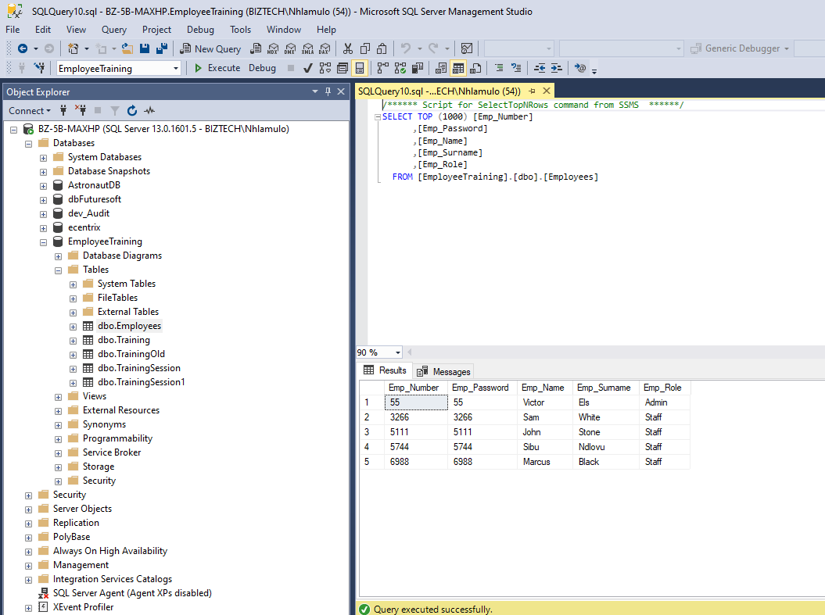

**Challenges**

* From Saturday afternoon and Sunday evening I did not have power(electricity) due to technical failure caused by a Heavy rain with Hail, but I have managed to spend a sleepless night trying to complete the assessment
* On my Master Page, at first I created my menu using bootstrap navs for it to be more responsive but I had a challenge where by the click event of my buttons were not firing, so I had to recreate the menu using normal CSS on my HTML master page. **(Screenshot for my bootstrap Menu attached below)**

**Home** 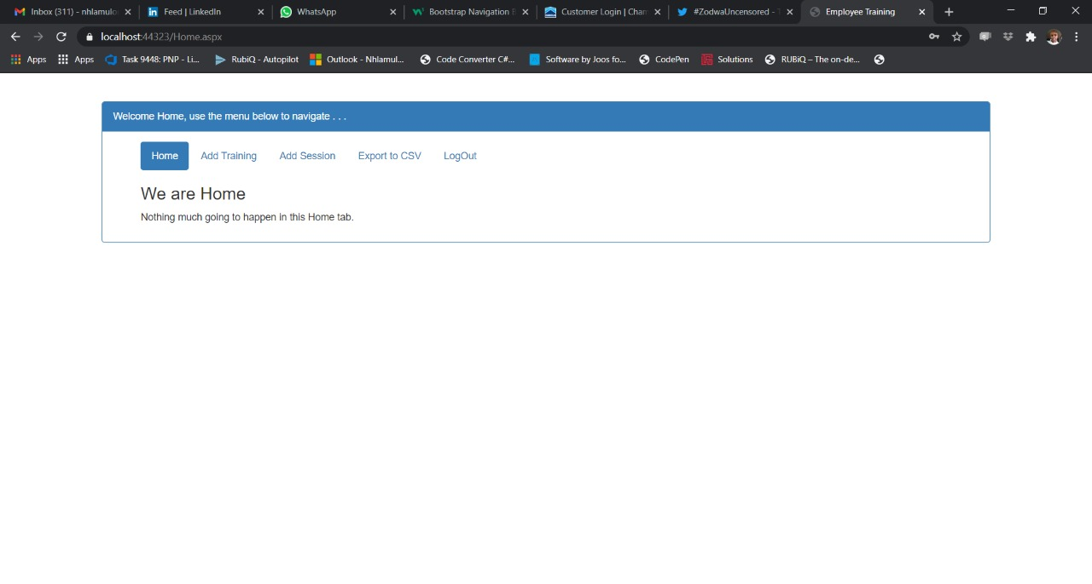

**Add Training**

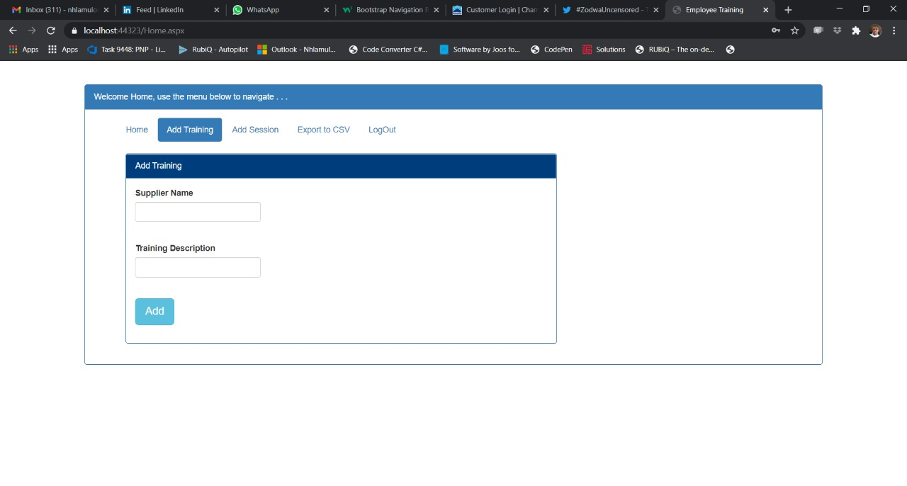

**Add Tarining Session**

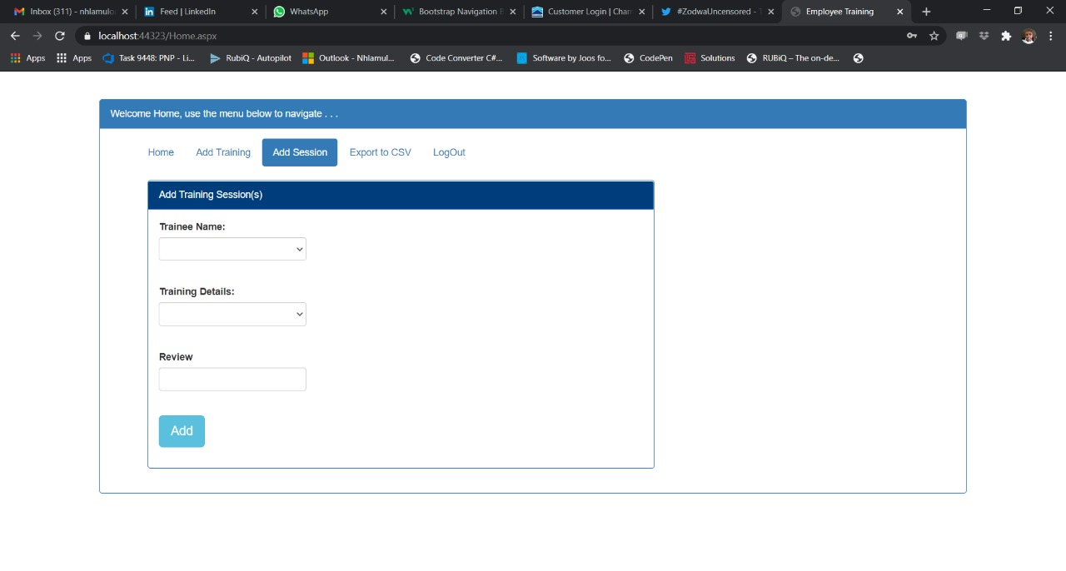

**Export to CSV and Logout** functionality were not yet done

